# PDLS User’s Manual

## System operation modes

### Static non-deflected mode

In this mode, the PDLS functions as a conventional linear time-of-flight mass spectrometer. Ions passing through the ion extraction optics are directed towards an ion detector located at the standard port. In this mode, no voltage is applied to the PDL-MS.

### Static deflection mode

In “Static deflection mode”, all ions are directed towards a time-of-flight (TOF) detector on the deflection port (D-port). A constant voltage is applied on the PDL to deflect the ions that have travelled past the ion extraction module. The selection slits can be adjusted to prevent ions of high-angle trajectories from reaching the detector on the D-port, which may improve MRP at the expense of signal. Neutral atoms will not reach detectors on the “Deflection path”.

This is a good mode for general TOF spectrometry.

### Pulsed deflection TOF mode

In pulsed deflection TOF mode, the pulser and delay generator are used to generate a voltage pulse on the PDL. This will allow ions within a narrow mass range to be deflected towards the “deflected port” (D-port), while the remaining ions continue to the “straight port” (S-port). The delay and width of the voltage pulse can be modified to select the mass range that is to be directed towards the D-port. The width of the selection slits can be adjusted to potentially improve MRP.

This can be used to direct strong low-mass signals to the S-port, and rarer high-mass signals to the D-port where sensitivity can be boosted at the expense of dynamic range.

In the schematic below, each of ions #1 – 5 have increasingly higher m/z. For a short time after the laser pulse, the PDL voltage is zero, and ion #1 travels to the S-port. Soon after the PDL voltage is raised to VD, ions #2 & #3 travel through the PDL and are deflected to the D-port. Ion #2 has a high-angle and is stopped by the slits, whereas ion #3 is detected. Ions #4 & #5 aren’t yet affected by the PDL voltage. If the PDL voltage is set to zero in time, then these ions will continue to the S-port.

## Pulsed deflection DOF mode

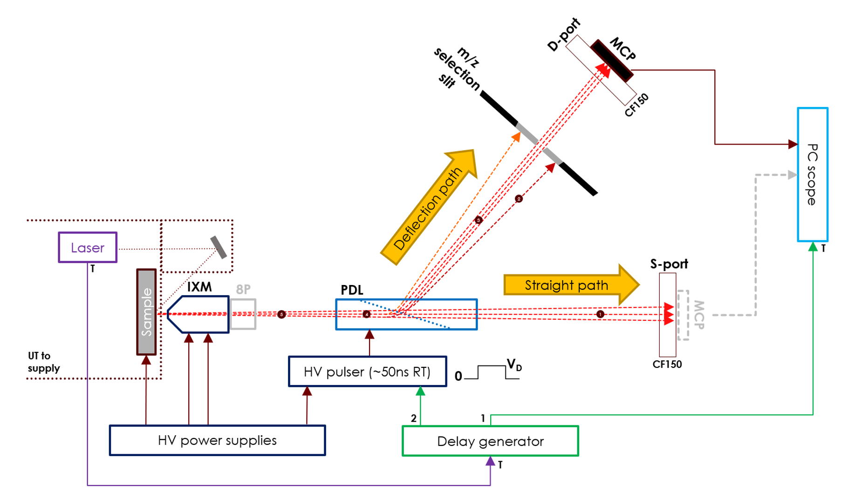

## Conditioning the Jordan TOF MCP

Steam’s High Voltage controller software can be used to control the voltage applied to the MCPs. Other software can be used such as LabView or serial communication (see Caen DT54xx user manual).

1. Make sure the Caen DT54xx unit is connected to computer via USB.
2. Open HV Controller software.

1. Open port to HV power supply. Function will be successful if unit model is displayed to user. (It may be helpful to check device manager first and determine which COM port is associated to DT54xx) (Maybe label above image with letters or numbers corresponding to key features required for the rest of the steps (i.e. the Open button could be marked ‘a’ etc. with a label) a legend for what all the acronyms are would also be useful).
2. If this is the first time operating the high voltage unit, ensure the hardware V Max is set to 2200 V. This is done by rotating the screw on the front panel of the unit.

1. Ensure no flags are red in status (verify that hardware switch is enabled). If any of the flags are red, mitigate the issue and select Clear (See above note on acronyms, if ‘UNV’ trips what am I looking for).

1. Start PicoScope and enable Channel A (channel that is connected to the MCP out).
2. Set trigger to Channel A at a threshold of approximately -50 mV and Trigger mode Auto.
3. Set:
   1. V Set to 1650 V
   2. I Set to 315 uA
   3. Ramp up to 5 V/s
4. Press ON. User will be prompted to confirm chamber vacuum is at appropriate level (< 10E-7 Torr?, something else?).
5. As VMon approaches VSet, watch the oscilloscope. If there are many continuous spikes, pause voltage rise and wait for them to disappear. Then set VSet to desired voltage again.
6. Once VMon reaches VSet, MCPs are ready to be used. The voltage can be modified by changing VSet and selecting the Set button.

## Setting the high voltages on the ion optics

1. Make sure Caen DT55xx high voltage supply is connected via USB to laptop and power is on.
2. Open GECO software and connect to high voltage supply DT55xx through COM port (you may need to verify in device manager which COM port is associated to the device).
3. Set the ion optics voltages to desired values The connections are as follows:
   1. HV1-Ch0 to Cone 1
   2. HV1-Ch1 to Lens 1
   3. HV1-Ch2 to PDL 1
   4. HV1-Ch3 to Sample
4. Select power on for each channel.

Recommended voltages for different operation modes (below)

|  |  |  |  |  |
| --- | --- | --- | --- | --- |
| **Operation Mode** | **HV1-Ch0 (V)** | **HV1-Ch1 (V)** | **HV1-Ch2 (V)** | **HV1-Ch3 (V)** |
| Static non-deflection | 700 | 850 | 0 | 1800 |
| Static deflection | 700 | 850 | 1340 | 1800 |
| Pulsed deflection | 700 | 850 | 4000 | 1800 |

## Setting up PicoScope and the oscilloscope

Initial settings for PicoScope to trigger from the laser OptoSync pulse should be as follows. These settings should be saved as the user start-up settings and can be loaded through File -> Start-up Setting -> Load User Default Settings.

Trigger settings:

* Source: AUX (connected to BNC Channel A)
* Mode: Repeat
* Level: 1 V (assuming trigger source is emitting 5V TTL and signal is terminated to 50 Ohms at oscilloscope)
* Trigger on rising edge
* Pre-trigger: 0%

Cable connections to the oscilloscope are as follows:

* PicoScope Channel A to MCP
* PicoScope AUX to BNC Channel A
* (Optional) PicoScope Channel C to Behlke pulser trigger out. This will decrease Sampling rate to 2.5 GS/s

## Setting up the oscilloscope and BNC for data acquisition

1. Turn the BNC (pulse generator) (Pic) on. The unit can be controlled by the buttons on the front panel or using TeraTerm (see BNC577 user manual for SCPI commands if controlling through TeraTerm). There are two values to adjust: the pulse delay and pulse width of Channel A. The BNC is set to trigger externally from OptoSync on the laser.
2. Start the BNC by pressing Run
3. Turn pulser switch on.
4. For static deflection, set the BNC delay to zero and the pulse width to over 80 us.
5. To enable the oscilloscope settings required for acquisition, in PicoScope go to File -> Start-up Settings -> Load User Default Settings. This will set appropriate trigger settings and voltage ranges for spectrum acquisition.
6. For maximum sampling rate on Channel A, connect the BNC Channel A to EXT on the oscilloscope. Disable all other channels and set the trigger source in PicoScope to EXT. The voltage resolution can also be modified to higher than 8 bits, this will however decrease sampling rate.

## Using the BNC remotely through TeraTerm

The BNC can be used remotely using the terminal program TeraTerm installed on the Laptop. Current settings have been saved to connect automatically to the BNC using COM8. If the BNC is unplugged or it’s COM port has changed, these settings will need to be changed.

TeraTerm is command based, each command is sent after a carriage return. If the response is ‘ok’ the command was successful. Otherwise, and error code will be sent.

The following are useful commands to send to the BNC for adjusting PDLS parameters:

1. Start the instrument,  
   :INST:STATE 1
2. Stop the instrument,  
   :INST:STATE 0
3. Set the pulse delay to 10 ns  
   :PULS2:DEL 1e-8
4. Set the pulse width to 1 us  
   :PULS2:WIDT 1e-6

## Diagram for all cable connections



## For averaging a fixed amount of spectra

1. In Tools -> Preferences, change the Maximum Waveforms to the number of pulses that the average should be taken over.  
   Graphical user interface, text, application

   Description automatically generated
2. In Tools -> Alarms, from the dropdown menu select Buffers Full. In the list of commands, unselect everything except Restart Capture. **Make sure the Buffers Full checkbox is checked.**

1. Press Ok and start capturing.

## For Burst mode and full data processing (alpha)

There is a process to sum a set amount of waveforms and convert to m/z vs intensity given our current calibrations. The program will acquire a set amount of waveforms, average them and save the average. A python script will then open the most recent file in the save directory, convert the average to a sum and output a file containing m/z vs counts. The waveforms are all saved to %userprofile%\Documents\waveforms\burst\. Do not change this directory as the location of the waveforms must be hard coded into the .bat script run by PicoScope. You can change the name of the saved files but ensure that the string “%time%” appears in the name and that the file is saved as a .csv. To conduct burst mode experiments and output m/z vs. Intensity curves, do the following:

1. Make sure an instance of PicoScope is running and connected to the oscilloscope. In PicoScope, make sure Channel A and average(A) are active.
2. In Tools -> Preferences, change the Maximum Waveforms to the number of pulses that will be output by the laser in a single burst.Graphical user interface, text, application

   Description automatically generated



1. In Tools -> Alarms, from the dropdown menu select Buffers Full.

1. Press OK.
2. Ensure trigger mode is Rapid and change number of acquisitions (textbox next to image of a rabbit) to the number of pulses in the laser burst mode.

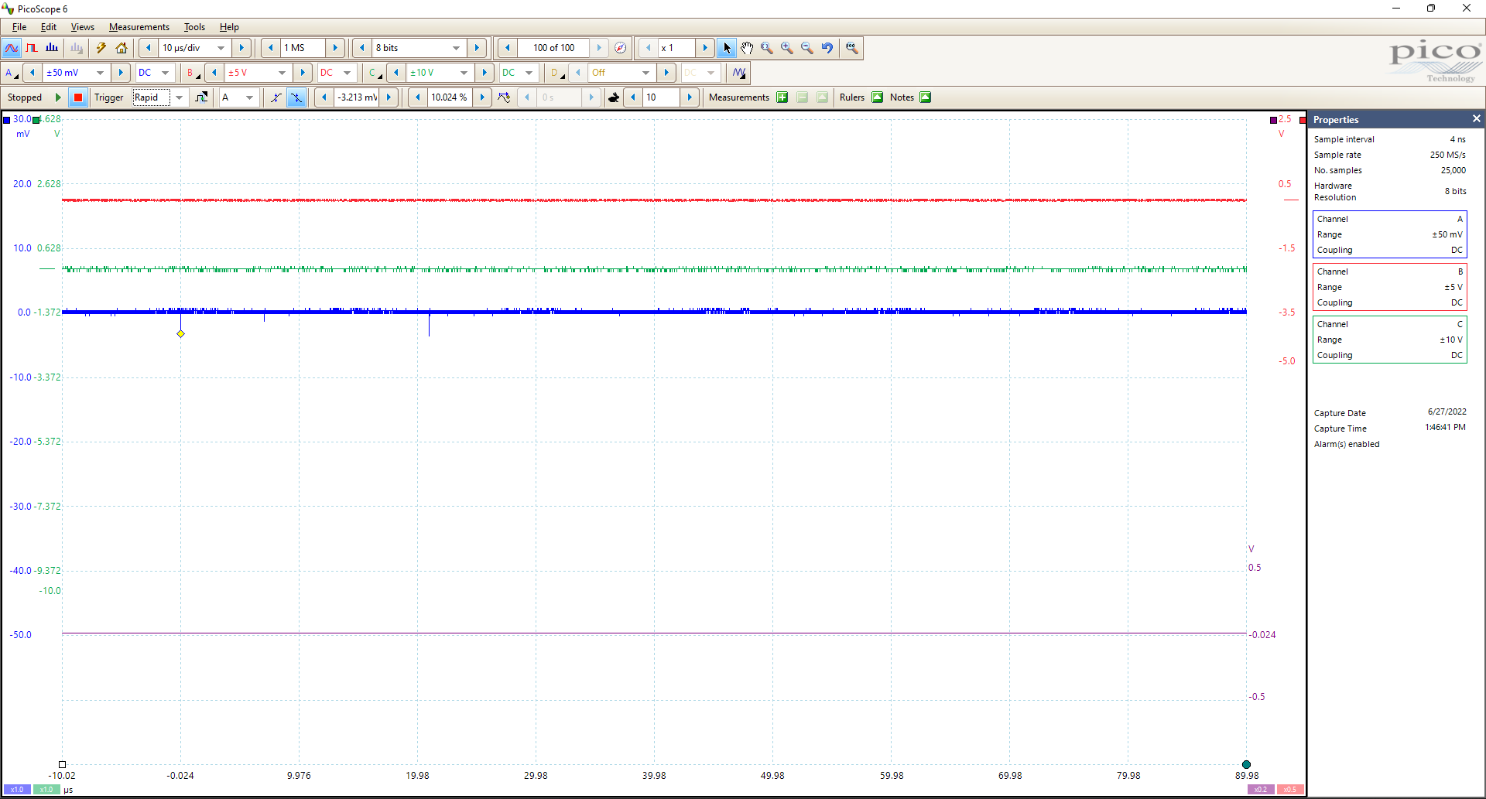

1. Once you are ready to begin acquisition, run the python file on the desktop titled runscope.py (double clicking on it will suffice)
2. You will be prompted for the number of waveforms to average over. Enter the number you have entered into the Maximum Buffers field and Rapid trigger field.
3. Press enter and capturing on PicoScope will begin. Now you can set a number of bursts on the laser using LWin and start acquisitions from LWin.

# Appendix

## List of Acronyms

MCP: Micro-Channel Plate

Etc. etc.